# Dharmam Buch

# DSB150030

# ASSIGNMENT 2 MACHINE LEARNING DECISION TREE

DataSet 1

|  |  |  |
| --- | --- | --- |
| Validation Data Accuracy | Test Data Accuracy | Number of Nodes To Be Pruned(K) |
| 72.300 | 74.100 | 0 |
|  | 69.9125(Avg) | 4 |
|  | 68.575(Avg) | 8 |
|  | 64.225(Avg) | 12 |
|  | 72.75 | 6 |

K = 4

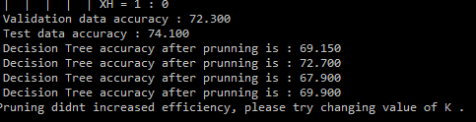

K = 8

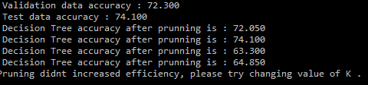

K=6

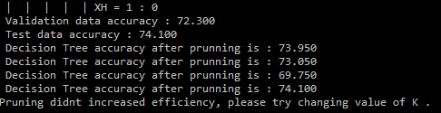

K=12

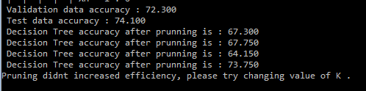

DataSet 2

|  |  |  |
| --- | --- | --- |
| Validation Data Accuracy | Test Data Accuracy | Number of Nodes To Be Pruned(K) |
| 72.300 | 74.100 | 0 |
|  | 72.1124(Avg) | 4 |
|  | 71.1(Avg) | 8 |
|  | 69.45(Avg) | 12 |
|  | 71.7375(Avg) | 6 |

K = 4

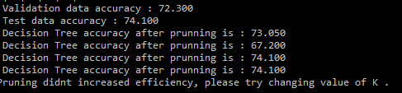

K = 8

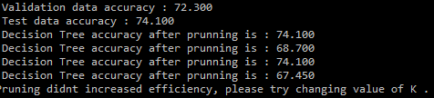

K=6

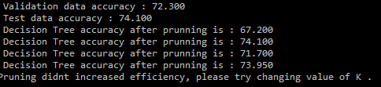

K=12

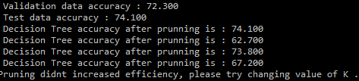

# Bonus

|  |  |  |
| --- | --- | --- |
| Number of  nodes  pruned | Accuracy of tree  constructed using  ID3 | Accuracy of tree  constructed using  random attribute  selection |
| 0 | 74.100 | 70.300 |
| 4 | 71.950 | 71.650 |
| 8 | 65.800 | 73.550 |
| 12 | 73.100 | 67.200 |
| 6 | 75 | 73.800 |



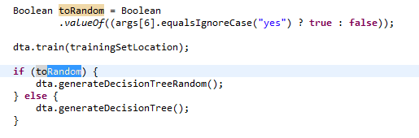

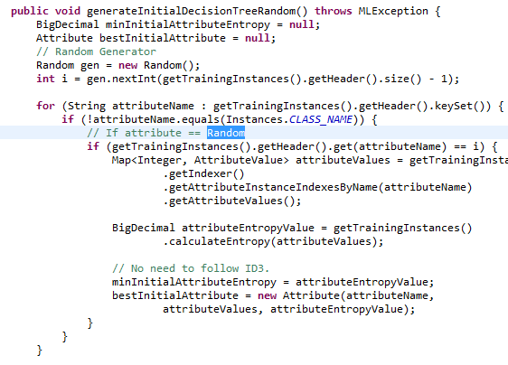

**Average Depth and Number of nodes : -**

With Random -

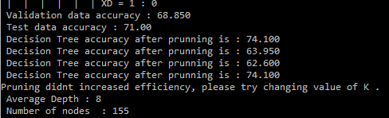

Without Random -

